Information Booklet

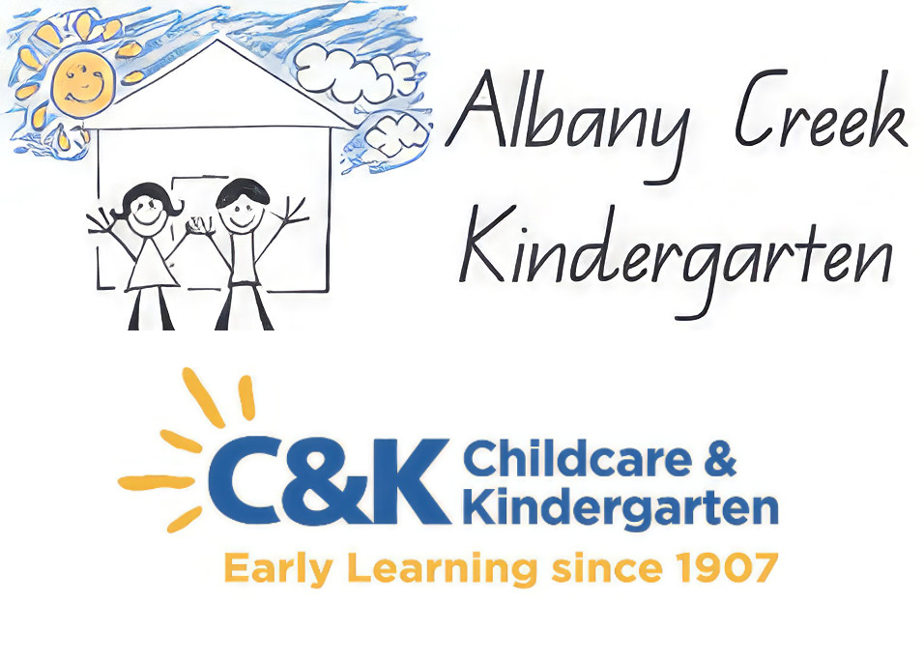

Albany Creek Kindergarten Association Inc.  
16 Ernie Street, Albany Creek Qld 4035  
P: 3264 1838 M: 0456 747 547  
E: [admin@albanycreekkindy.com.au](mailto:admin@albanycreekkindy.com.au)  
W: [www.albanycreekkindy.com.au](http://www.albanycreekkindy.com.au)

Albany Creek Kindergarten

  

**TABLE OF CONTENTS**

SECTION ONE

Welcome to Albany Creek Kindergarten

Program Times

Our Mission & Philosophy Statements

SECTION TWO

National Quality Framework

Licensing

Contact Details

Staff

SECTION THREE

Curriculum

SECTION FOUR

Initial Separation

What to bring

What to Wear

Arrival and Departure

Hygiene practices

Rest and Relaxation Time

Lost Property

Lending Library

Entertainment, Excursions, and Escorted Journeys

SECTION FIVE

Policies

Workplace Health and Safety

Sun Protection

Health Information

SECTION 6

Family Involvement

Toddlers at Kindergarten

Management Committee

SECTION 7

Enrolment, Fees and Administration

Funding and Expenditure

Special Events & Fundraising

Centre grounds Maintenance

Fees

SECTION EIGHT

Communication, Concerns and Complaints (grievance procedure)

Section One

# **Welcome to Albany Creek Kindergarten**

# ***We would like to acknowledge and pay respects to the Turrbal people, the traditional custodians of the land on which our kindergarten is placed. We acknowledge and pay respects to all elders past, present and emerging. With compassionate hearts, we honour the past, to teach for the present and build for the future.***

# Welcome to Albany Creek Kindergarten and congratulations on choosing an Affiliated C&K Community Kindergarten. Your family is now part of a long tradition in quality early childhood education and care. C&K has been advocating for young children and providing community-based early childhood services since 1907.

##### Albany Creek Kindergarten has been serving the local community since 1972 when it originally operated in the local Salvation Army Hall. The kindergarten then moved to its present site in 1979. We became incorporated on the 16th August 1984. Our land and building are leased through the City of Moreton Bay Council.

##### We only have to look at the wonderful facilities available to the children at our Kindergarten to realise the achievement of those families and staff who started with nothing but the desire to provide the very best in early years education for the children of Albany Creek. The current Committee and Staff strive to maintain this vision and is confident that full enrolments and the operational viability of the Kindergarten will be maintained.

##### Albany Creek Kindergarten is a non-profit organisation. We are a double unit Centre and follow the State School year with the same term breaks. All Kindergarten groups are offered 600 hours of an Approved Kindergarten Program.

### **Kindergarten Program Times**

|  |  |
| --- | --- |
| Unit 1 | Unit 2 |
| **2 DAY PROGRAM**Monday and Tuesday8:00am – 3:30pm | **5 DAY FORTNIGHT PROGRAM**Monday, Tuesday and (alt) Wednesday8:40am - 2:45pm |
| **3 DAY PROGRAM**Wednesday, Thursday and Friday8:15am - 2.45pm | **5 DAY FORTNIGHT PROGRAM**Thursday, Friday and (alt) Wednesday8:40am - 2:45pm |

##### We ask families to please note these hours as we cannot take responsibility for children outside of these times. The times before and after the program are very valuable to Staff for the planning and preparation of the program.

# 

# **Our Mission Statement**

# Our mission at Albany Creek Kindergarten is to provide children with a **PLAY** enriched environment and build **PARTNERSHIPS** with families and the community. We strive for **HIGH QUALITY** early childhood education and care where we support children to become **LIFE-LONG LEARNERS**.

**Our Philosophy**

# **Section Two**

## **National Quality Framework** In 2009 the Council of Australian Governments (COAG) signed an agreement to unify all states and territories with one early childhood regulatory and quality assurance process. The National Quality Framework (NQF) for early childhood education and care was implemented from 1 January 2012 and governs these national changes.

##### The NQF recognises the importance of quality experiences for children in the early years to ensure their present and future health, wellbeing, development and learning.

##### The key aspect of the NQF is continuous improvement. At Albany Creek Kindergarten we are committed to continuous improvement to ensure a quality program is provided and improved outcomes for your child. We use a Quality Improvement Plan (QIP) to detail our strengths, areas for improvement, strategies to improve practice and progress towards achieving goals. Our QIP is always available to families and we welcome your feedback and contributions.

##### Early in 2021 we were assessed under the NQF and received a rating of EXCEEDING National Quality Standards.

##### Our provider Approval Number is PR-00000458 and our Service Approval Number is QSA-740002.

## **Licensing** All centres and home-based services are governed by the Education and Care Services National Regulations 2018.

##### All early childhood education and care and home-based services across Australia must comply with this legislation and engage in a rigorous assessment process to achieve and maintain approval. This legislation, the NQS and the NQF are available at the Kindergarten for families and educators to access at any time.

##### All services (including Albany Creek Kindergarten) must meet legislated requirements for experiences and programs, number of educators and children, and educator qualifications.

##### In QLD, early childhood officers (ECO’s) from the Department of Education, Training and Employment Early Childhood Education and Care regularly visit services to monitor compliance with the legislation. All services in QLD are required to maintain a log book of any official compliance notices they receive from the Office. All families have a right to access the log book upon request. Albany Creek Kindergartens Compliance Log Book is kept in the office; if you wish to view this document please see Staff.

### **For more information, contact:** Dept. of Education, Training and Employment Early Childhood Education and Care Metro North Region, North Lakes Office Level 3, 10 The Corso, North Lakes Qld 4509 Phone: 07-5433 6106

Email: [MNRNorthlakes.ECRA@qed.qld.gov.au](mailto:MNRNorthlakes.ECRA@qed.qld.gov.au)

### **C&K Support** C&K representatives visit our affiliated service on a regular basis to provide support to the staff, families and children. We are able to access support across wide topic areas including curriculum; wellbeing and inclusion; policies; marketing; workplace, health and safety; assessment and rating and professional development.

##### Albany Creek’s C&K representatives can be contacted at: C&K (Central Office) 257 Gympie Road, Kedron QLD 4031

##### Phone: 1800 177 092

## **Staff** Our staff are highly experienced and qualified, to work as a cohesive team. The Centre supports the ongoing professional development of all staff through attendance at courses, seminars, workshops and conferences. All staff hold a current First Aid Certificate and relevant Suitability/Blue cards. Please see office staff for full job descriptions.

## **Director(s)/Nominated Supervisor/ Educational Leader** The Director(s) facilitates the provision of a high-quality early childhood education and care service. This involves but is not limited to, conducting educator training and professional development, guiding the implementation of the Early Years Learning Framework, Queensland Kindergarten Learning Guidelines and the C&K Curriculum Approach and ensuring that effective day-to-day operations of the service are maintained. Directors hold early childhood qualifications and meet the minimum requirements to hold a nominated supervisor’s position as outlined in the Education and Care Services National Law Act and the Education and Care Services National Regulations. The Director(s) also keeps the management committee (the employer of the Association) informed about the Centre and works closely with the committee giving guidance and advice on professional matters.

## **Early Childhood Teacher(s)** All Early Childhood Teachers are university-qualified and develop and implement an educational program in collaboration with children and families. They get to know your child and assess your child’s strengths, needs and interests. The staff then uses this information; combines it with theories of child development and learning and their own professional background, to provide an educational program for individuals and groups of children.

## **Teaching Assistant(s)** Teaching assistants work within the classroom supporting the teacher in implementing the educational program. Assistants hold an early childhood qualification.

## **Inclusion Support Worker(s)** C&K is committed to providing inclusive environments and programs to meet the diverse needs of all children and their families. Within each classroom, there may be an inclusion support worker working with the teaching team to support children throughout the educational program. These workers may have a variety of qualifications and experiences.

## **Administrators** Administration staff are responsible to the management committee and attend to the administrative tasks of the Centre to support the Committee and Educators.

##### 

# **Section Three**

## **Curriculum** Our quality early childhood programs are based on the C&K Curriculum Approach, the Early Years Learning Framework (EYLF) and Queensland Kindergarten Learning Guidelines (QKLG). These reflect the latest research in early childhood education.

## **C&K Curriculum Approach** Early childhood curriculum has been crafted by C&K educators with and alongside children, families and communities for over 110 years. Curriculum in C&K early childhood centres is shaped by a strong set of shared values, commitments and visions that honour children. A distinguishing feature of the curriculum in C&K centres is the way that educators skilfully partner with children and families to create caring and vibrant learning communities. The purpose of the *Listening and Learning Together: C&K Curriculum Approach* is to set out the values, commitments and visions for children’s learning that underpin curriculum in C&K centres and to support educators’ to bring these to life in ways that realise the expectations described in *The Early Years Learning Framework for Australia* (EYLF), and the *Queensland Kindergarten Learning Guidelines* (QKLG).

##### There are five key principles in the C&K Approach that shape pedagogy and practice: relationships, partnerships, equity, diversity and professional inquiry. The guiding principles reflect contemporary research and understandings of teaching and children’s learning. These five principles are interconnected and inform dynamic practice and decision-making that progresses children’s learning. (Extracts from the C&K Curriculum Approach (2019)).

## **Documenting your child’s learning** Educators will document and assess your child’s learning through a variety of methods:

##### • Observations that focus on social interactions, relationships and learning processes

##### • Writing, drawing and painting

##### • Sound and image recordings

##### • Stories and photographs of group and individual projects

##### • Contributions from families

##### Each child will have a Portfolio that will document their learning journey. It will include many of the above documenting methods and allow children to have the opportunity to revisit and reflect on past experiences; record their own learning; and share their learning with others. Children and families are encouraged to contribute to these portfolios.

# **Section Four**

## **Initial Separation –**

## Albany Creek Kindergarten provides additional support in each room during the early weeks to ensure a smooth transition for all children.

##### For the first few days, help your child to find their locker and to unpack by placing their lunch box in the fridge, washer in the bathroom and washing their hands. After this initial period, the children will be encouraged to do this by themselves to build independence skills in preparation for Prep.

##### Please allow a little time so your child can show you things and places that interest them. When it is time, say goodbye firmly, reassuring them that you will be back after lunch and a rest. Don’t prolong the farewell. Your child may show emotion at this initial break, but prolonging your departure or having long discussions about their crying makes it harder. Always farewell staff, so we know you are leaving. A staff member will quickly step in at this stage. This will enable us to give your child a little extra support should they need it at this time.

##### If your child is having problems separating it is not a good idea to “socialize” within sight of the children. A wave at the door and then quickly leaving is best on these first days. Most children stop crying within minutes of the parent leaving, so don’t focus on tears. Your child’s teacher will always contact you if your child continues to be distressed. If you do leave your child crying, please feel free to ring us back in a half hour or so. This applies at any stage throughout the year.

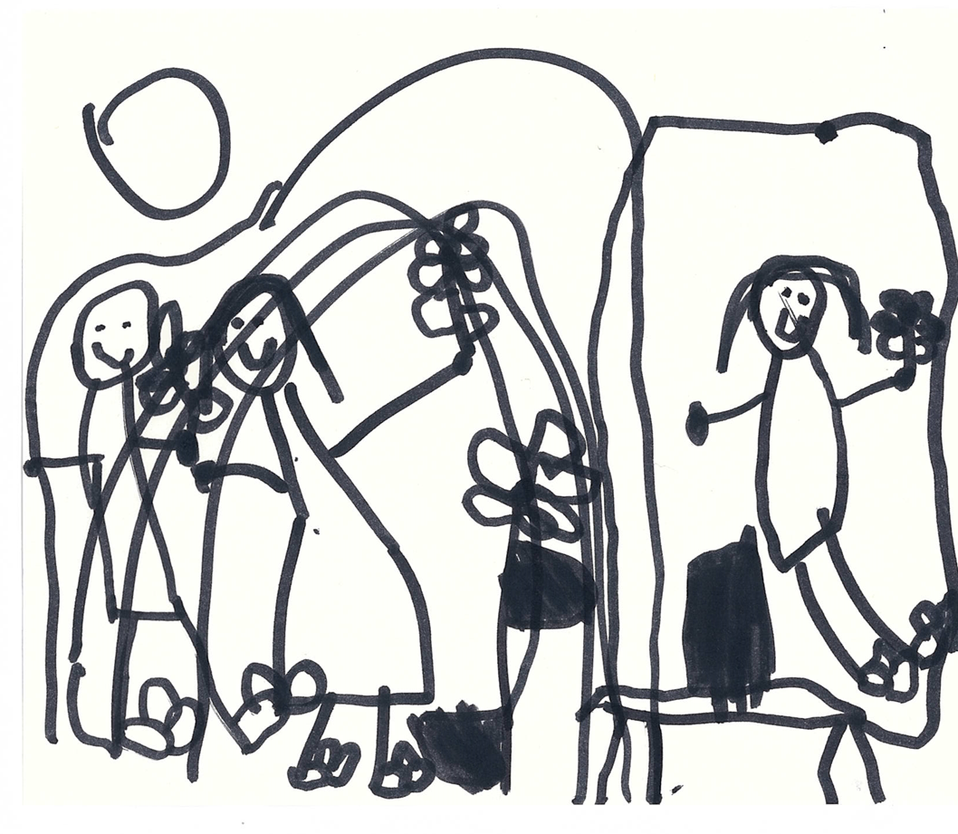What to bring  
Please make sure all belongings are named, especially clothes, socks and shoes.

##### A Kindergarten bag that is easy for your child to open by themself. This encourages their sense of independence. This bag should be large enough to accommodate a lunch box, hat, spare clothes, bed sheets etc

##### A lunch box, which is readily recognized by your child (perhaps with a special sticker). Once again, easily opened by your child. Do not send cooler bags to Kindergarten as refrigerators are provided. Children need lunch and morning tea to be packed together in one lunch box; the lunch box must be labelled with the child’s name. We ask that all children bring a litterless lunch box. (This is in keeping with our aim to reduce waste and meet the requirements of our sustainability goals). We encourage all lunch boxes to contain healthy options and avoid sending sweet snacks and treats. This will assist us in the implementation of our healthy eating program and promote good health, growth and development in future years.

##### A clear water bottle suitable for your child to easily access water during the day. A clear water bottle ensures we can easily monitor how much water your child is drinking.

##### A face washer with a loop/ring in the middle of the washer so that the washers don’t touch each other while hanging (ensure you see the sample). This is used by children to dry their hands after washing.

##### 5. Shoes/sandals that are taken off for outside play as a safety precaution when children use climbing equipment and to allow children to explore freely and develop sensory awareness.

##### 6. A sun-safe hat. This is essential! The hat must protect the back of the neck as well as the face- wide-brimmed, bucket style or legionnaire hats – no caps. Hats must be worn all year during outdoor play. The Cancer Council recommends a brim of 7.5cms. We have bucket-style hats and Kindergarten t-shirts on sale at the office all year round.

##### 7. Spare clothes are essential. Water is a valuable play medium and is part of our outdoor program (weather permitting). Children can also become wet and muddy as they dig in the sand.

##### 8. Set of sheets and drawstring bag. See pattern available from staff or purchase a set from the centre. We also have a limited number of second-hand sheets available.

##### 9. A library bag. Approximately the same measurements as the sheet bag, but no smaller.

## **What to Wear** Old/play clothes are a must! It is requested that children dress as simply as possible in sun safe (shoulders covered) clothes they can manage themselves. This will enable freedom of movement and expel fear of becoming dirty. Children will be involved in many valuable play experiences throughout the day, including messy play activities. During Bush Kindy excursions children are asked to wear long pants and enclosed shoes, reef/beach shoes are a great option.

## **Shoes versus Bare Feet** This centre recognizes the benefits of bare-footed play for children's safety, growth, and the development of sensory awareness. Shoes can be a hazard in outdoor play areas. The child needs bare feet to grip as they climb. Nerve endings in the feet can sense the quality of different surfaces, the grass and the concrete, and sand between the toes. Bare feet can also be important for indoor activities, for freedom of movement, for sensory experience detecting different textures on the floor, for better balance and physical control and for lowering noise levels. **Please DO NOT send light-up shoes that contain button batteries.**

##### Children can be encouraged to remove shoes themselves which is an independence skill to be fostered. Your child is welcome to put their shoes on once inside, if they choose.

## **Arrival and Departure** It is required that children be brought to the centre and collected by a responsible adult of at least 18 years of age. The C&K Association recognize the value of child-free time before and after the daily program. During this time the teaching teams prepare the environment, maintain their written program and administrative records, conduct staff meetings, attend regional meetings and tidy up. These additional duties serve to enhance the quality of the program offered to parents and children. In accordance with the Centre’s By-Laws (due to insurance purposes) the Centre shall not be responsible for any child outside the attendance hours. Parents' co-operation is sought in keeping to the session times as outlined in Section One. Constant disregard of the finishing time will result in the child’s enrolment at Kindergarten being re-examined as well as a late fee being charged. Late fees are charged at a flat rate of $20 for the first 10 minutes or any part thereof, and an additional $1.50/minute will be charged for any subsequent time.

##### For safety reasons, it is imperative that parents/carers, notify staff of changes to collection arrangements. Alternate carers must be added as emergency contacts, via the Parent Portal. All individuals who are listed as emergency contacts must have their own individual Konnect log-in. Signing your child in and out of the service is required by law and must be complied with under the terms of our license.

## **Parking** For the safety of our families please always hold your child/ren’s hands outside the kindergarten gate. Please, do not park in the driveway of the Centre as it is a safety risk to parents and children entering and if emergency vehicles need to be able to gain access. No Parking is permitted in the area marked by the yellow line at the end of the cal-de-sac or in disabled car parks without a permit.

## **Hygiene practices** The highest standard of hygiene practices is implemented at Albany Creek Kindergarten. These include:

##### Parents and children are requested to wash their hands thoroughly when arriving and departing the Kindergarten. This will minimize the risk of cross-infection and maintain good hygiene practices. Hand sanitiser is provided for adults at each entry gate.

##### A strict hand washing procedure for staff upon arrival, before and after wiping children’s noses, before and after serving food or administrating medication and after cleaning equipment.

##### Gloves are worn by adults for any bodily fluids, and children are to wash their hands after blowing noses, toileting, eating etc.

##### The use of separate sheets, beds, washers and tissues for each child encourages children in keeping the environment clean, tidy and hygienic.

##### A professional cleaner is employed by the Kindergarten to clean at the end of each day.

## **Rest and Relaxation Time** After a very busy program of physical and mental stimulation, a necessary and important element of the program is an opportunity for the children to rest, relax and reflect on their day. The room is darkened and some quiet music and/or stories help to set the mood. The children are encouraged to rest and relax their bodies. It is not mandatory for them to sleep. Some children feel more comfortable with a sheepskin or teddy bear from home. Please discuss your child’s needs with your teacher.

## **Lost Property** Please see your child’s teachers if any personal belongings are misplaced. We are very keen to find the appropriate owners, so please name everything!

## **Toys and Treasures from Home**

##### The centre provides a great variety of developmentally appropriate play equipment. The children are not encouraged to bring toys or other “treasures” from home, such as jewellery, as they may become lost or damaged. This only causes heartache. We do, however, encourage the children to bring natural, interesting items such as shells, flowers, insects and other special finds, as these add to our program. These items can be left on our interest tables.

**Button Batteries**

Do not bring any item into the centre that contains button batteries such as electronic toys, children’s watches or shoes with flashing lights.

## **Children’s Lending Library** We have a library day for each group each week. We rely on parents to assist in teaching children to take proper care of the books. Books must be carried in a special library bag. Reading is a special time that parents and care givers can spend with their child and encourages children to develop an interest in language, and a love of books. Please notify us if you find a problem with any book borrowed.

## Parent’s Library We have a number of very worthwhile books and videos to lend. These may be borrowed for one week. Please make a note in the book if you require an extension.

## **Environmentally Friendly** We strive to promote conservation and sustainability. Children are encouraged to care for animals and to protect their environment. The use of fresh food is encouraged for lunch and morning teas to reduce the overuse of packaging. Please limit the use of plastic bags within your child’s kindergarten bag e.g. cloth bag to contain spare clothes. This is a health and safety issue to reduce children’s exposure to plastic.

##### We encourage the collection of junk to be recycled as art materials in the centre. Please see the staff for a list of preferred items. Please let us know if you have access to supplies of paper that we could use for the children’s art work (as you can imagine how much we go through!) supplies of pine off –cuts suitable for carpentry would also be appreciated.

##### Pest control is carried out annually during vacation times.

##### **Students, Work Experience Visitors and Volunteers** This centre recognizes the importance of University and TAFE student placements as being consistent with the long term training of staff in the provision of quality education and care for children. However, acceptance of placement of students must be determined upon consideration of the children’s needs at the time.

##### During the year, students from surrounding high schools complete work experience time at the centre. This is implemented on a limited basis upon request from the school liaison officer and in consultation with the teachers.

##### This centre may accept placement of volunteers but only after the commitment to students has been met and after full investigation of the person concerned. Volunteers will work under the guidance of qualified staff. All students/work experience visitors must carry a current “Blue Card” and comply with the C&K Covid-19 vaccination and management staffing policy.

##### On arrival, all visitors MUST sign the visitor’s book or access the Konnect sign-in system in the foyer, and peruse the folder entitled “Visitors Log.” This is a regulation of the Workplace Health and Safety Policy of this kindergarten. This policy can be found in the foyer, and should be read by all visitors.

##### **Entertainment, Excursions, and Escorted Journeys** The teachers at this Centre prefer to invite performers and visitors to the centre to minimise costs and maximise the chance of all the children being able to participate. All Entertainment providers are carefully screened and are only chosen if they are relevant to the needs and interests of the children.

A ‘Bush Kindy’ program is integrated into the Kindergarten program during terms 2 and 3. Bush kindy occurs on a fortnightly basis. The bush area directly behind the kindergarten is used for these excursions.

## Families will be notified if the children are to go on an excursion or outing. Permission slips for each excursion must be signed by the parent or guardian prior to departure.

##### These will have details of: Purpose of the excursion

##### Time of departure and proposed time of arrival; Mode of transport; Destination; Adult: Child ratio

# **SECTION FIVE**

## **Policies: Keeping our children happy, healthy and safe.** Albany Creek Kindergarten, in conjunction with C&K, has developed a range of policies to support educators and families to deliver the highest quality education and care. These policies address a broad range of issues and we strongly encourage you to access the C&K policies available at the Kindergarten or via [www.candk.asn.au](http://www.candk.asn.au/) and follow the “Kindergarten” links to the “C&K Policy” tab. These policies address a broad range of topic areas: <https://www.candk.asn.au/policies>

##### C&K policies are developed and reviewed using a thorough process of consultation with input from families, C&K policy reference groups, and relevant agencies including government departments and health officials.

##### Current legislation, as well as information and advice from recognised authorities and feedback from educators, are all used during policy review and development. We encourage all families to contribute to policy review and invite you to share your thoughts and feelings through suggestion boxes, feedback forms, committee meetings, surveys and day/reflection books.

## **Child Protection**

## C&K has developed comprehensive and detailed policies and procedures to ensure your child is safe in a C&K service. C&K practices comply with all relevant state / territory and federal legislation. C&K demonstrates its commitment to child protection with a dedicated early childhood advisory team to support educators, children and families in the areas of child protection and children with additional needs and the NQS. All Albany Creek Kindergarten educators are trained in child protection procedures annually and are provided with a variety of resources and development opportunities. All C&K educators and employees are mandated to report suspected child abuse. The policy can be found on the C&K website or by following this link:

<https://www.candk.asn.au/sites/default/files/Policies_Procedures/Child%20Protection%20Policy_0.pdf>

## **Workplace Health and Safety** Albany Creek Kindergarten has policies and procedures in place to ensure the optimal level of safety is maintained and relevant legislation is complied with. Professional cleaners are employed to clean our centre daily when children are not present. An experienced maintenance employee maintains the outdoor area and maintenance tasks. The Albany Creek Kindergarten elects a Workplace Health and Safety officer at the AGM to oversee WH&S in our service and works in conjunction with the elected Maintenance officer and staff to continually monitor and ensure a safe and healthy environment.

##### Other safety procedures include:

##### Staff conducting daily Safety Checklists

##### Ensuring all hazardous materials are kept in locked cupboards

##### Filling out incident report forms to document injuries

##### WH&S checks carried out monthly

##### Training staff in accident and emergency procedures

##### Ensuring that all safety devices are installed and maintained

##### Requiring all permanent staff to hold a current First Aid aid certificate.

##### Should you have a concern about any safety issue please see your teaching team. Please access and read our Workplace Health and Safety booklet in the resources section of our website- [www.albanycreekkindy.com.au](http://www.albanycreekkindy.com.au)

##### **Lock Down/Evacuation / Fire Drill Procedures:** Lockdown, evacuation and fire drills are regularly carried out according to regulations. All staff are given adequate instructions on the use of fire safety equipment and lockdown procedures.

##### Sign your child in via Konnect upon arrival.

##### If in the building when the alarm sounds, EVACUATE with the class, and follow staff instructions.

##### DO NOT ENTER the building if the alarm is sounding;

##### Read the Workplace, Health and Safety booklet on our webpage; and

##### Evacuation plans are located in both units and throughout the centre.

## **Sun Protection** Albany Creek Kindergarten is recognised by the Cancer Council as a Sun Smart Centre and we have procedures and policies in place to ensure children are protected from the damaging effects of the sun during their attendance at the centre.

##### Sunscreen is provided in the dispensers installed near the sign-in areas. It is the parents’/carers' responsibility to apply sunscreen to their child each morning and sign the Sunscreen Register.

## **Educators will ensure that children are:**

##### Wearing an appropriate wide-brimmed hat or legionnaire’s cap at all times during outdoor activities. The hat must ensure your child has clear vision and that cords do not pose a safety risk.

##### Include in the program discussions about sun protection and encouraging children to be independent in sun safe behaviour.

##### Model sun-protective behaviour.

## **Health Information** As most parents are aware, it is essential to keep your child home when they are ill. Parents are asked to remember that colds and flu are contagious. When unwell, children are not able to concentrate or participate in the program and may present a risk to themselves and others, including staff.

##### The last occurrence of vomiting/diarrhoea must be at least 24 hours prior to the child re-attending the environment. Children who have had paracetamol for a temperature must not re-enter the centre until 24 hours without a temperature or any paracetamol to reduce the temperature. Children who are over-tired or who have been sick during the night (eg vomiting and diarrhoea) should not attend the centre the following day.

##### The final decision for the daily attendance of a child rests with the staff. The director/s are authorised to refuse admittance to a child showing symptoms of an illness, which may affect the health of other children attending Kindergarten.

##### Whenever your child comes into contact with an infectious or contagious disease, or have had a COVID-19 test please notify staff.

##### In the event of a child becoming ill in the centre, the parent will be contacted. Therefore, it is imperative that the parent ensures the current telephone numbers, including mobiles, are with the staff at all times. In the event of a parent or contact not being available, the staff will take whatever steps are considered necessary to ensure the child’s wellbeing. If deemed necessary, the teachers will contact ambulance transportation or medical assistance. Parent and emergency phone contact numbers are kept on a readily accessible register. Parents of an injured child will be contacted promptly. An Incident Register is kept at the centre to comply with the Workplace Health and Safety Regulations.

##### Please refer to the “Time out” brochure in the Resources section of our website [www.albanycreekkindy.com.au](http://www.albanycreekkindy.com.au) , “Procedure SO:01.06- Exclusion due to illness procedure” <https://www.candk.asn.au/sites/default/files/Policies_Procedures/Exclusion%20due%20to%20illness%20Procedure_1.pdf>

##### To support our commitment to the happiness, health and safety of all children, teachers/educators and visitors we ask that you follow displayed health and safety posers and the C&K COVID Commitment Statement guidelines. <https://www.candk.asn.au/search/node/commitment>

## **Immunisation** As part of the C&K enrolment procedure, parents/guardians are required to provide evidence of their child’s immunisation status. Parents/guardians are also required to update the service’s record at the time of each immunisation thereafter. If unsure of immunisation history, the parent/guardian must seek advice from your child’s registered medical practitioner or the Australian Childhood Immunisation Register (my.gov.au)

##### C&K recognises that not all parents/guardians can or wish to have their child immunised. Parents/guardians of non-immunised children must detail this in the enrolment booklet. Parents/ guardians of non-immunised children must be aware that in the event of an outbreak of a vaccine preventable infectious disease, their child will be required to remain at home if this is the advice provided to C&K by the Public Health Unit. The immunisation schedule is available in the resources section of our website [www.albanycreekkindy.com.au](http://www.albanycreekkindy.com.au) .

**Medication**  
All families, visitors and staff must abide by the Workplace Health & Safety Statement, and the procedure NQS2: Administration of Medication. The staff will administer prescribed medication **only** when it is absolutely necessary and essential for the child’s wellbeing. Prescribed medicines must carry the prescribed child’s name on the medication and the doses prescribed for that child by the Doctor. In such circumstances medical and legal forms must be completed by the child’s Doctor and both parents. A daily medication book must be signed and to ensure the safety of children, parents need to set out clear dosages and times.

**We cannot give non-prescribed medicines such as cough medicines or analgesics. However, if you feel your child needs medicine such as this, you are welcome to come to the centre and administer it yourself to your child. Please speak to your child’s teacher if you have any concerns regarding this, including creams and insect repellent.**

Prior written consent by the parent is required before one (1) initial dose of paracetamol. Paracetamol will only be administered if parents or authorised emergency contacts cannot be contacted and the child’s temperature has reached or exceeded 38.5 degrees Celsius. When a child is unwell and a fever is present the parent or emergency contact will be required to collect the child from Kindergarten. When there is no fever apparent, **paracetamol cannot** be administered, even on request of a parent/guardian as a precautionary measure.  Children are not allowed to bring cough lollies or lip balm of any kind. Staff will store medication in a tamper-proof box.

Caring for children with chronic conditions  
If your child has a medical condition, such as anaphylaxis, asthma, diabetes or epilepsy please provide the Kindergarten with a detailed medical management plan from your child’s registered medical practitioner. Please use the online enrolment booklet to detail information and begin conversations with educators. Upon enrolment, we will ask you to meet with your child’s educator/s to further discuss the Medical Management Plan and complete all necessary paperwork.

SECTION 6

## **Family Involvement** This centre recognizes the important role played by parents in the education of their children and values parent participation and involvement on a variety of levels e.g. sharing skills and interests in the educational program, joining the daily program, attending parent meetings and social functions and becoming involved at a committee management level.

##### This is a Community Kindergarten with a voluntary parent participation program giving every parent (mother or father) the opportunity to share their child’s experiences during a Kindergarten day.

##### The aims of the program are:

##### To show your child that you are interested in what he/she is doing, thus combining Kindergarten and family interests;

##### To enable you to understand and share in your child’s learning.

##### To encourage common and wider talking points away from kindergarten.

##### To help you understand, more fully, aspects of child development and education; and

##### To enable ideas to be exchanged with teachers, advice to be given, and opinions to be shared.

##### At the beginning of each term parents will have the opportunity to nominate a day on which they wish to attend the kindergarten for the day or part day and assist the teacher and sit with their own child participating in the learning program. Roster times ensure that there is a comfortable number of adults in the centre at any one time.

## **Privacy** Parents please note that parents/grandparents participating on classroom roster should be aware that any information acquired whilst on roster, is protected by the Privacy Act and therefore should not be repeated. Please remember that you see only a small section of the ongoing program for the development of all children.

## **Toddlers at Kindergarten** Toddlers are welcome to join in all activities with parent supervision. We do ask that you keep them with you during story and music and any other group activity time, as they can be a distraction to the other children. We remind parents that whilst they are at our centre they are responsible for their own children.

## **Management Committee** Albany Creek Kindergarten is a Community owned Centre operated by a parent committee. It is affiliated with C&K. All profits are put back into the centre.

##### The Annual General Meeting of the Kindergarten Association is usually held at the centre in February/March each year. At this, a Management Committee of twelve current members is elected by the Parent Body, to run the kindergarten for the next 12 months. The Executive Committee of four members are elected first as the custodians of the centre for the year and a general Committee of eight to support the Executive Committee.

##### After this meeting the Management Committee meets monthly during school terms to carry out its functions.

##### Even for those who have not served on Committees before, help is available from the staff at the centre, former Committee members & the C&K Association. If you feel you could contribute in this way, please do not hesitate to talk to the Office Administrators, Director or current committee members.

### **Committee Position Descriptions**

##### All parents are eligible to nominate for one of these positions

|  |  |
| --- | --- |
| **EXECUTIVE COMMITTEE** |  |
| **PRESIDENT** | General Management of the centre as part of the Management committeeResponsible for the staff and employment of staffChairs monthly meetings.Acts as liaison between director/staff /parents and the Committee.Oversees the management of finances, fundraising activities & public relations. |
| **VICE PRESIDENT** | General Management of the centre as part of the Management committeeResponsible for the staff and employment of staffTo share responsibilities with the President and act on his/her behalf in, the absence of the President.Assist in the application of grant proposals. |
| **SECRETARY** | General Management of the centre as part of the Management committeeResponsible for the staff and employment of staffTo record minutes of monthly meetings & present them to each subsequent meeting.To assist with correspondence following Meetings. |
| **TREASURER** | General Management of the centreResponsible for the staff and employment of staffTo present an annual budget and monitor all financial aspects of the Kindergarten.To present the accounts of the kindergarten for the year & liaise with the Auditor. |

|  |  |
| --- | --- |
| **GENERAL COMMITTEE** |  |
| **WORKPLACE HEALTH & SAFETY & CHILD PROTECTION OFFICER****(TWO PEOPLE TO SHARE THIS ROLE)** | Is responsible for overseeing the relevant policies and building planning and maintenance. Responsible for overseeing Child Protection policies and updates. |
| **MARKETING OFFICER** | To promote the kindergarten depending on our requirements each year to ensure we keep our enrolments at the centre full. Ensure website is kept up to date. |
| **NEWSLETTER CO-ORDINATOR** | Collates & distributes monthly newsletter.Liaise with community to promote the kindergarten. |
| **MAINTENANCE COORDINATOR** | To be responsible for working bees, To assist in the promotion and activities of the Kindergarten driven Community Bush Care Group Co-ordinate working bees twice a year. |
| **SPECIAL EVENTS COORDINATOR****(TWO PEOPLE TO SHARE THIS ROLE)** | Acts on behalf of the Committee to implement social/special interest activities.Record all activities and transactions. |
| **BOOK CLUB COORDINATOR** | Collect and distribute book club brochures.Collate orders and distribute via class teachers. |

##### **SECTION 7**

## **Enrolment, Fees and Administration** This Centre is a non-profit community-based Centre. The management and financial control is organised by the Management Committee of elected parents who oversee the maintenance, finances and educational standards requirements.

##### A copy of the Constitution and By-Laws can be found on the parent library stand in the foyer for your perusal or on our website [www.albanycreekkindy.com.au](http://www.albanycreekkindy.com.au)

## **Special Events** The Events Coordinator seeks the assistance and involvement of parents in organising activities to raise money for the Centre. A sub-committee can be formed to plan and coordinate the activities for the year. It is this Centre’s policy that the Coordinator and their committee handle all events. To ensure that parents only receive what the Events Committee has coordinated we ask that any private businesses advertise via our Community notice board.

## **Fund Raising Policy** We recognize that many businesses could benefit the Centre in some way. It is our policy that all items for fundraising for that year will be submitted in writing to the events committee prior to the 3rd week of term one. These submissions will be collated and discussed at the first meeting of the year, after the AGM Meeting, to select the yearly events.

## **Grounds & General Maintenance** The Centre remains a safe, attractive environment for our children.

##### The parents of this Centre can support in maintaining the building, grounds and indoor and outdoor equipment. You are invited to participate in this upkeep through working bees held at least twice a year or through offering your services at a convenient time.

##### Please raise any maintenance issues you observe at the Centre with staff, so the safety of everyone is ensured.

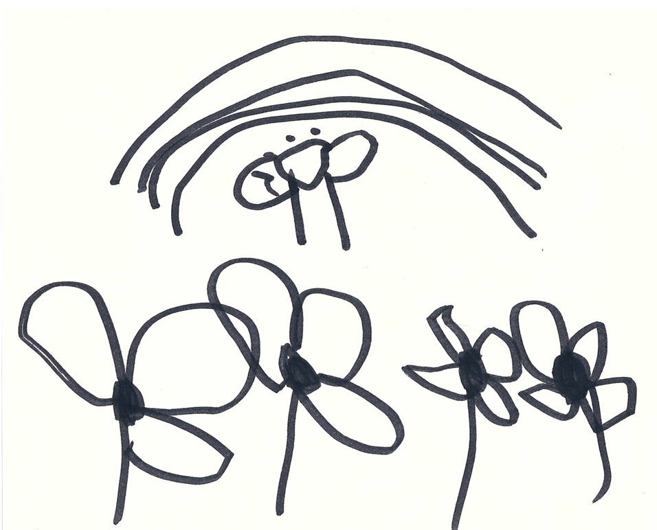

## **Fees for additional hours, 3 day program** As a not for profit organisation our fees are kept to a minimum and are payable via a Direct debit system called “idebit pro”. This helps us to streamline how we process fees and make it easier on families. With Direct Debit your kindergarten fees are automatically deducted from your nominated bank account, credit or debit card at the frequency nominated by parents in their online Enrolment book.

##### Fees, above the ‘FREE’ 15 hours per week, are set by the Management Committee. Any problems or concerns with meeting the fees can be discussed with the Administrators and confidential arrangements will be made. Should an account or fee instalment not be paid by the due date, enrolment can be terminated to allow another child on the waiting list to be enrolled.

##### Absences due to illness or family holidays are charged at the usual rate. If your child is absent for two weeks and no reason for the absence has been advised, continued enrolment will be re-evaluated. If you wish to terminate the enrolment, you should do so in writing, giving at least two week’s advance notice.

##### **NOTE: ‘FREE KINDY’ applies to all children attending 15 hours per week or 30 hours per fortnight.**

## **Building Fund** The Centre has a registered Building Fund and voluntary donations to this fund are a tax deduction and are gratefully received. Any donations are used towards building maintenance. A receipt will be issued.

## **Enrolment /Membership/Administration Fee** A $100.00 (non-refundable) Enrolment/Association Membership/Administration Fee is charged at the time of accepting an enrolment.

## This fee covers administrative costs of $90 per child, and an annual Membership fee of $10 00. The membership fee covers your financial membership to the Albany Creek Kindergarten Association Inc for the year. One family member can then vote at the Annual General Meeting and become a Voting Committee member. All members are welcome at our committee meetings throughout the year, however, only committee members for that year get a voting right.

SECTION EIGHT

## **Communication** Ensuring families are well informed and passing on as much information as possible to support families is a high priority at Albany Creek Kindergarten. We therefore provide open lines of communication through the following mediums:

##### Notice boards located in each unit, in the main foyer of the centre and the main verandah.

##### Communication pockets near the entry in each unit.

##### Emails from Centre committee, Nominated Supervisor/Educational Leader, Administration and classroom educators.

##### Centre and Class newsletters

##### Daily Journals to communicate about the classes’ day and learning journey.

##### Individual Portfolios

##### Formal and informal discussions.

## **Concerns and complaints (grievance procedure)**

##### Where a parent has any concerns regarding their child or child’s program, the first direct contact should be with the Classroom Teacher. If this does not resolve your issue you may contact the Nominated Supervisor of the Centre or the Management Committee. If necessary, a representative from our central governing body, C&K, may be asked to assist the Centre with any unresolved issues.

##### Any written concerns will be addressed in the strictest of confidence by the Management Committee. Submit all written correspondence to:

##### The President, Albany Creek Kindergarten 16 Ernie Street Albany Creek Qld 4035 E: [admin@albanycreekkindy.com.au](mailto:admin@albanycreekkindy.com.au)